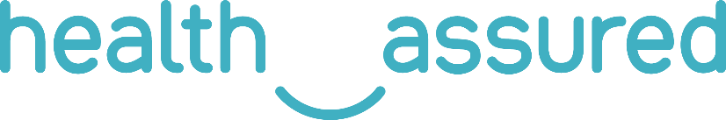

The health and wellbeing of our team members is paramount. We are therefore proud to offer you all access to an Employee Assistance Programme (EAP), delivered by Health Assured – the UK and Ireland’s leading wellbeing provider.

**What is an Employee Assistance Programme (EAP)?**

An EAP is a confidential employee benefit designed to help you deal with personal and professional problems that could be affecting your home life or work life, health, and general wellbeing.

Our EAP service provides a complete support network that offers expert advice and compassionate guidance 24/7, covering a wide range of issues. We strongly believe in providing an EAP service that offers not only reactive support when someone needs it but also proactive and preventative support to deliver the best possible outcomes.

**With Health Assured there really is a better way**

Balancing everyday life with the requirements of work and home can create pressures for all of us. Work is a large part of people’s lives. With increasing working hours as well as technological developments to support remote working, it is vital to ensure that there is a productive, healthy environment that is conducive to a healthy lifestyle.

**Services Available**

* Life support: Access to counselling for emotional problems and a pathway to structured therapy sessions (employees only) at your convenience.
* Legal information: For issues that cause anxiety or distress including debt management, consumer, property or neighbour disputes (employees only).
* Bereavement support: Health Assured offers qualified and experienced counsellors who can help with grief plus legal advisors to help with related legal matters.
* Medical information: Qualified nurses are on hand to offer support on a range of medical or health-related issues offering practical information and advice.
* Online CBT: We recognise the value of self-help tools in dealing with a range of issues, which is why we have a range of CBT self-help modules, informative fact sheets and invaluable advice videos from leading qualified counsellors.

**Helpline services available**

Health Assured also offers support for you and your immediate family members*, 24 hours a day, 7 days a week, 365 days a year by calling **XXXX**.

*\*Health Assured define immediate family members as spouse/partners and children aged 16 to 24 in full-time education, living in the same household.*

**Introducing the *My Healthy Advantage* smartphone app**

In addition to the EAP, we are excited to offer you all access to *My Healthy Advantage*, Health Assured’s comprehensive health and wellbeing app.

Through *My Healthy Advantage*, you will have access to a range of features, all aimed at improving your health and wellbeing. These include:

* **Live chat and support**
* **Personalised news feed**
* **Weekly mood tracker**
* **Four-week plans**
* **Mini health checks**
* **Breathing techniques**

Available for [iOS](https://apps.apple.com/gb/app/my-healthy-advantage/id1484810687) and [Android](https://play.google.com/store/apps/details?id=com.healthassured.app&hl=en_GB) devices, you can access *My Healthy Advantage* with the following login credentials:

**Unique code: XXXX**

Our app will also give you access to **BrightTV** - an exclusive series featuring well-known personalities sharing their personal experiences with mental health. Including **Dame Kelly Holmes, Ruby Wax OBE, Andy Reid MBE, Sally Gunnell OBE, Gemma Oaten** and **Carrie & Clarke Carlisle**.

**Wellbeing Portal**

In addition to counselling support, advice and our app, we also offer a virtual library of wellbeing information. Our articles and self-help guides provide support on a range of health and advisory issues, as well as instant guidance to aid your physical and mental health.

To access the Wellbeing Portal you will require the below login credentials:

Username: **XXXXX**

Password: **XXXXX**